1. Design Patterns  
   Creational -> How should objects to be created, hide implementation of the object, only reveal its interface  
   Structural-> how should classes behave and interact with each other  
   Behavioral -> how objects behave and interact with each other
2. Creational Design pattern: deals with the process of creation of objects of classes
3. 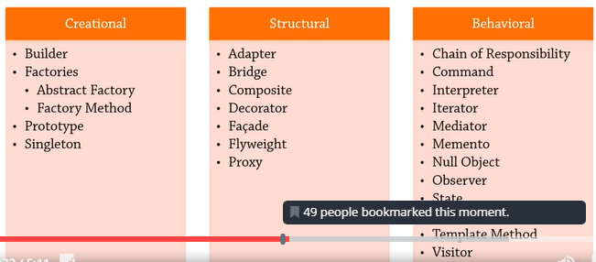
4. Builder Design Pattern: We remove the logic related to object creation code from client code and abstract it into a separate class  
   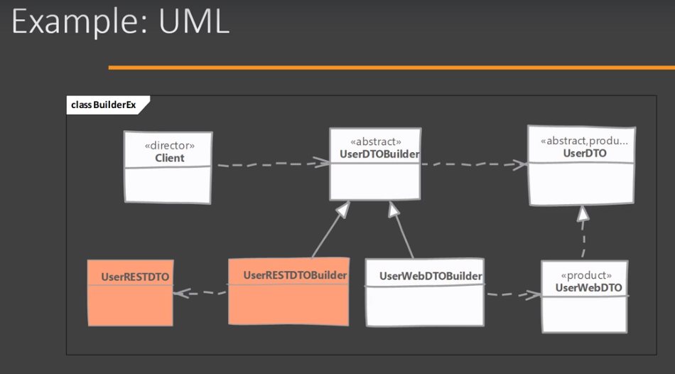
5. Design principles: Rely on interfaces, open close principle
6. Page Object Model:
7. Strategy Design Pattern:  
   Defining characteristics: uses member variables than inheritance and objects implement interfaces  
   Strategy pattern is closely related to command pattern and dependency injection pattern  
   Eg: a) Comparator  
   b) Database Connection using JDBC